LAB #18

Process messages with Azure Service Bus
AI workflows often rely on messaging to decouple request intake from model inference and to route results to multiple downstream consumers. Azure Service Bus provides the reliability and routing layer that connects these components so each piece can scale and fail independently.
In this exercise, you create an Azure Service Bus namespace and build a Python Flask web application that demonstrates core messaging patterns using an AI inference scenario. You work with queues to send and receive inference requests using peek-lock delivery, inspect the dead-letter queue for malformed payloads that failed processing, and use topics with filtered subscriptions to fan out inference results by priority level.
Tasks performed in this exercise:
- Download the project starter files
- Create an Azure Service Bus namespace and messaging entities
- Add code to the starter files to complete the app
- Run the app to perform messaging operations
This exercise takes approximately 30 minutes to complete.
Before you start
To complete the exercise, you need:
- An Azure subscription. If you don't already have one, you can sign up for one.
- Visual Studio Code on one of the supported platforms.
- Python 3.12 or greater.
- The latest version of the Azure CLI.
Download project starter files and deploy Azure Service Bus
In this section you download the starter files for the app and use a script to deploy an Azure Service Bus namespace and messaging entities to your subscription.
- Open a browser and enter the following URL to download the starter file. The file will be saved in your default download location.
TypeCopy
https://github.com/MicrosoftLearning/mslearn-azure-ai/raw/main/downloads/python/service-bus-python.zip
- Copy, or move, the file to a location in your system where you want to work on the project. Then unzip the file into a folder.
- Launch Visual Studio Code (VS Code) and select File > Open Folder… in the menu, then choose the folder containing the project files.
- The project contains deployment scripts for both Bash (azdeploy.sh) and PowerShell (azdeploy.ps1). Open the appropriate file for your environment and change the two values at the top of the script to meet your needs, then save your changes. Note: Do not change anything else in the script.
TypeCopy
$rg = "ResourceGroup1" # Resource Group name
$location = "<your-azure-region>" # Azure region for the resources
- In the menu bar select Terminal > New Terminal to open a terminal window in VS Code.
- Run the following command to login to your Azure account. Answer the prompts to select your Azure account and subscription for the exercise.
TypeCopy
az login
- Run the following command to ensure your subscription has the necessary resource provider for the exercise.
TypeCopy
az provider register --namespace Microsoft.ServiceBus

- Run the appropriate command in the terminal to launch the script.
Bash
bashTypeCopy
bash azdeploy.sh
PowerShell
powershellTypeCopy
./azdeploy.ps1

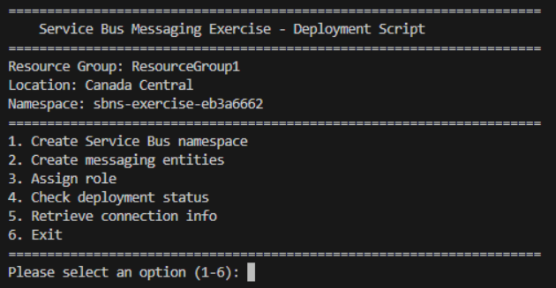

Note: If PowerShell blocks the script because it is not digitally signed, run the following command in the same terminal session, then run the deployment script again. This command changes the execution policy only for the current PowerShell process.
powershellTypeCopy
Set-ExecutionPolicy -Scope Process -ExecutionPolicy Bypass
- When the script is running, enter 1 to launch the 1. Create Service Bus namespace option.
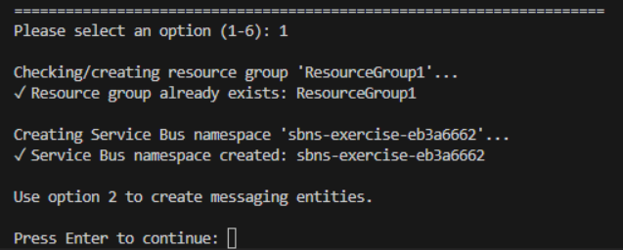
This option creates the resource group if it doesn't already exist, and deploys an Azure Service Bus namespace with the Standard tier. The namespace is the container for all messaging entities you create during the exercise.
- Enter 2 to run the 2. Create messaging entities option. This creates the queue, topic, subscriptions, and SQL filter that the app uses. The inference-requests queue is configured with a max delivery count of 5 and dead-lettering on message expiration. The inference-results topic has two subscriptions: notifications (receives all messages) and high-priority (filtered to only receive messages where the priority property equals high).
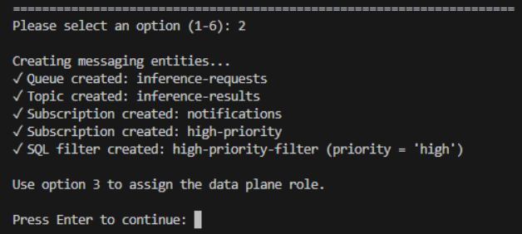
- Enter 3 to run the 3. Assign role option. This assigns the Azure Service Bus Data Owner role to your account so you can send and receive messages using Microsoft Entra authentication.
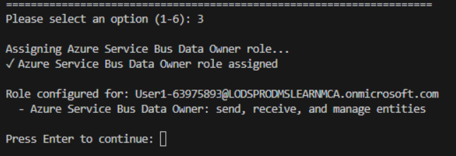
- Enter 4 to run the 4. Check deployment status option. Verify the namespace status shows Succeeded, the messaging entities are created, and the role is assigned before continuing. If the namespace is still provisioning, wait a moment and try again.
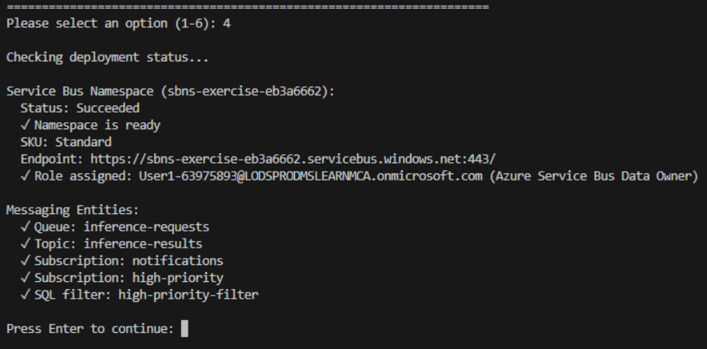
- Enter 5 to run the 5. Retrieve connection info option. This creates the environment variable file with the fully qualified domain name (FQDN) needed by the app.
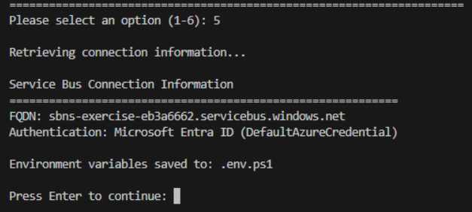
=====================================================================
Please select an option (1-6): 5

Retrieving connection information...

Service Bus Connection Information
===========================================================
FQDN: sbns-exercise-eb3a6662.servicebus.windows.net
Authentication: Microsoft Entra ID (DefaultAzureCredential)

Environment variables saved to: .env.ps1



- Enter 6 to exit the deployment script.
- Run the appropriate command to load the environment variables into your terminal session from the file created in a previous step.
Bash
bashTypeCopy
source .env
PowerShell
powershellTypeCopy
. .\.env.ps1
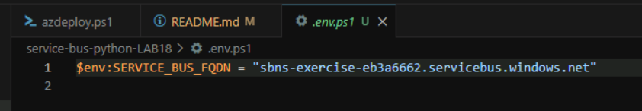
Note: Keep the terminal open. If you close it and create a new terminal, you need to run this command again to reload the environment variables.
Complete the app
In this section you add code to the service_bus_functions.py file to complete the Service Bus messaging functions. The Flask app in app.py calls these functions and displays the results in the browser. You run the app later in the exercise.
- Open the client/service_bus_functions.py file to begin adding code.
Note: The code blocks you add to the application should align with the comment for that section of the code.
Add code to send messages to the queue
In this section, you add code to send three messages to the queue. Two messages have valid JSON payloads representing inference requests, and one has intentionally malformed JSON to simulate a processing failure that demonstrates the dead-letter queue.
The function opens a ServiceBusClient using DefaultAzureCredential and creates a queue sender with get_queue_sender(). It constructs three ServiceBusMessage objects, each with a message_id for deduplication, a correlation_id for tracking, and application_properties for custom metadata. Two messages contain valid JSON payloads and one contains intentionally malformed JSON. The send_messages() method sends each message individually to the queue.
- Locate the # BEGIN SEND MESSAGES FUNCTION comment and add the following code under the comment. Be sure to check for proper code alignment.
pythonTypeCopy
def send_messages():
"""Send messages to the queue including one malformed message."""
# Create a ServiceBusClient using DefaultAzureCredential
client = get_client()
results = []

with client:
# Open a sender bound to the queue
with client.get_queue_sender(QUEUE_NAME) as sender:
# Valid message 1 — message_id enables deduplication,
# correlation_id links related messages for tracking,
# and application_properties carry custom metadata for routing
msg1 = ServiceBusMessage(
body=json.dumps({
"prompt": "Extract parties and effective date.",
"model": "gpt-4o",
"document_id": "doc-001"
}),
content_type="application/json",
message_id=str(uuid.uuid4()),
correlation_id="req-doc-001",
application_properties={"priority": "standard", "document_type": "contract"}
)
sender.send_messages(msg1)
results.append({
"correlation_id": msg1.correlation_id,
"type": "valid",
"status": "sent"
})

# Valid message 2 — priority is set to "high" so it matches
# the SQL filter on the high-priority topic subscription
msg2 = ServiceBusMessage(
body=json.dumps({
"prompt": "Summarize the key terms.",
"model": "gpt-4o",
"document_id": "doc-002"
}),
content_type="application/json",
message_id=str(uuid.uuid4()),
correlation_id="req-doc-002",
application_properties={"priority": "high", "document_type": "contract"}
)
sender.send_messages(msg2)
results.append({
"correlation_id": msg2.correlation_id,
"type": "valid",
"status": "sent"
})

# Invalid message — intentionally malformed JSON body to
# demonstrate dead-lettering during processing
msg3 = ServiceBusMessage(
body="not valid json: [broken",
content_type="application/json",
message_id=str(uuid.uuid4()),
correlation_id="req-doc-003",
application_properties={"priority": "standard"}
)
sender.send_messages(msg3)
results.append({
"correlation_id": msg3.correlation_id,
"type": "malformed",
"status": "sent"
})

return results
- Take a few minutes to review the code.
Add code to process messages with peek-lock
In this section, you add code to receive messages from the queue using peek-lock mode. The processor validates the JSON payload, completes valid messages, and dead-letters messages with invalid JSON by providing a reason and error description.
The function creates a queue receiver with get_queue_receiver() using peek-lock mode (the default), which locks each message while it's being processed but keeps it in the queue until settlement. For each message, it attempts to parse the JSON body. Valid messages are removed from the queue with complete_message(). Invalid messages are moved to the dead-letter sub-queue with dead_letter_message(), which accepts a reason and error_description for diagnostics.
- Locate the # BEGIN PROCESS MESSAGES FUNCTION comment and add the following code under the comment. Be sure to check for proper code alignment.
pythonTypeCopy
def process_messages():
"""Receive and process messages from the queue using peek-lock."""
client = get_client()
results = []

with client:
# Peek-lock is the default receive mode — the message is locked
# but stays in the queue until explicitly completed or dead-lettered.
# max_wait_time sets how long the receiver waits for new messages.
with client.get_queue_receiver(
queue_name=QUEUE_NAME,
max_wait_time=5
) as receiver:
for msg in receiver:
try:
payload = json.loads(str(msg))
# Complete removes the message from the queue
receiver.complete_message(msg)
results.append({
"correlation_id": msg.correlation_id,
"document_id": payload.get("document_id"),
"model": payload.get("model"),
"prompt": payload.get("prompt", "")[:50],
"status": "completed"
})
except json.JSONDecodeError:
# Dead-letter moves the message to the dead-letter
# sub-queue with a reason and description for diagnostics
receiver.dead_letter_message(
msg,
reason="MalformedPayload",
error_description="Message body is not valid JSON"
)
results.append({
"correlation_id": msg.correlation_id,
"document_id": None,
"model": None,
"prompt": str(msg)[:50],
"status": "dead-lettered"
})

return results
- Save your changes and take a few minutes to review the code.
Add code to inspect the dead-letter queue
In this section, you add code to read messages from the dead-letter queue and display diagnostic information. The dead-letter queue captures messages that couldn't be processed, along with the reason and error description for troubleshooting.
The function creates a receiver that targets the dead-letter sub-queue by passing sub_queue=ServiceBusSubQueue.DEAD_LETTER to get_queue_receiver(). For each dead-lettered message, it reads the diagnostic properties: dead_letter_reason, dead_letter_error_description, and delivery_count. After reading, it calls complete_message() to remove the message from the dead-letter queue.
- Locate the # BEGIN INSPECT DLQ FUNCTION comment and add the following code under the comment. Be sure to check for proper code alignment.
pythonTypeCopy
def inspect_dead_letter_queue():
"""Inspect and remove messages from the dead-letter queue."""
client = get_client()
results = []

with client:
# ServiceBusSubQueue.DEAD_LETTER targets the dead-letter sub-queue,
# which holds messages that failed processing
with client.get_queue_receiver(
queue_name=QUEUE_NAME,
sub_queue=ServiceBusSubQueue.DEAD_LETTER,
max_wait_time=5
) as dlq_receiver:
for msg in dlq_receiver:
# Dead-lettered messages include diagnostic properties:
# dead_letter_reason, dead_letter_error_description,
# and delivery_count (number of delivery attempts)
results.append({
"message_id": msg.message_id,
"correlation_id": msg.correlation_id,
"dead_letter_reason": msg.dead_letter_reason,
"error_description": msg.dead_letter_error_description,
"delivery_count": msg.delivery_count,
"body": str(msg)[:100]
})
# Complete removes the message from the dead-letter queue
dlq_receiver.complete_message(msg)

return results
- Save your changes and take a few minutes to review the code.
Add code for topic messaging with filtered subscriptions
In this section, you add code to send messages to a topic with different priority levels, then receive from each subscription to verify that filtering works. The notifications subscription receives all messages, while the high-priority subscription receives only messages where the priority application property equals high.
The function uses get_topic_sender() to open a sender bound to the topic, then sends five messages with varying priority values in their application_properties. It then opens two subscription receivers with get_subscription_receiver(). The notifications subscription has no filter and receives all five messages. The high-priority subscription only delivers messages that match its SQL filter. Note that application properties may arrive as bytes due to AMQP encoding, so the code handles both string and bytes keys.
- Locate the # BEGIN TOPIC MESSAGING FUNCTION comment and add the following code under the comment. Be sure to check for proper code alignment.
pythonTypeCopy
def topic_messaging():
"""Send messages to a topic and receive from filtered subscriptions."""
client = get_client()
sent = []
notifications = []
high_priority = []

with client:
# get_topic_sender opens a sender bound to a topic instead of a queue.
# Each message is broadcast to all matching subscriptions.
with client.get_topic_sender(TOPIC_NAME) as sender:
for i, priority in enumerate(["standard", "high", "standard", "high", "low"]):
result = {
"document_id": f"doc-{i+1:03d}",
"status": "completed",
"confidence": 0.95
}
# The "priority" application property is what the SQL
# filter on the high-priority subscription evaluates
msg = ServiceBusMessage(
body=json.dumps(result),
content_type="application/json",
message_id=str(uuid.uuid4()),
application_properties={"priority": priority}
)
sender.send_messages(msg)
sent.append({
"document_id": f"doc-{i+1:03d}",
"priority": priority
})

# Receive from the notifications subscription, which has no filter
# and therefore receives all messages sent to the topic
with client.get_subscription_receiver(
topic_name=TOPIC_NAME,
subscription_name="notifications",
max_wait_time=5
) as receiver:
for msg in receiver:
body = json.loads(str(msg))
# Application properties may arrive as bytes depending
# on the AMQP encoding, so handle both str and bytes keys
props = msg.application_properties or {}
priority_val = props.get("priority") or props.get(b"priority", b"unknown")
if isinstance(priority_val, bytes):
priority_val = priority_val.decode("utf-8")
notifications.append({
"document_id": body["document_id"],
"priority": priority_val
})
receiver.complete_message(msg)

# Receive from the high-priority subscription, which only delivers
# messages where the SQL filter "priority = 'high'" matches
with client.get_subscription_receiver(
topic_name=TOPIC_NAME,
subscription_name="high-priority",
max_wait_time=5
) as receiver:
for msg in receiver:
body = json.loads(str(msg))
props = msg.application_properties or {}
priority_val = props.get("priority") or props.get(b"priority", b"unknown")
if isinstance(priority_val, bytes):
priority_val = priority_val.decode("utf-8")
high_priority.append({
"document_id": body["document_id"],
"priority": priority_val
})
receiver.complete_message(msg)

return {
"sent": sent,
"notifications": notifications,
"high_priority": high_priority
}
- Save your changes and take a few minutes to review the code.
Configure the Python environment
In this section, you navigate to the client app directory, create the Python environment, and install the dependencies.
- Run the following command in the VS Code terminal to navigate to the client directory.
TypeCopy
cd client
- Run the following command to create the Python environment.
TypeCopy
python -m venv .venv
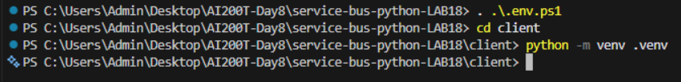
- Run the following command to activate the Python environment. Note: On Linux/macOS, use the Bash command. On Windows, use the PowerShell command. If using Git Bash on Windows, use source .venv/Scripts/activate.
Bash
bashTypeCopy
source .venv/bin/activate
PowerShell
powershellTypeCopy
.\.venv\Scripts\Activate.ps1
- Run the following command in the VS Code terminal to install the dependencies.
TypeCopy
pip install -r requirements.txt
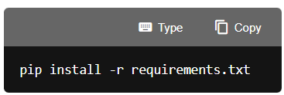
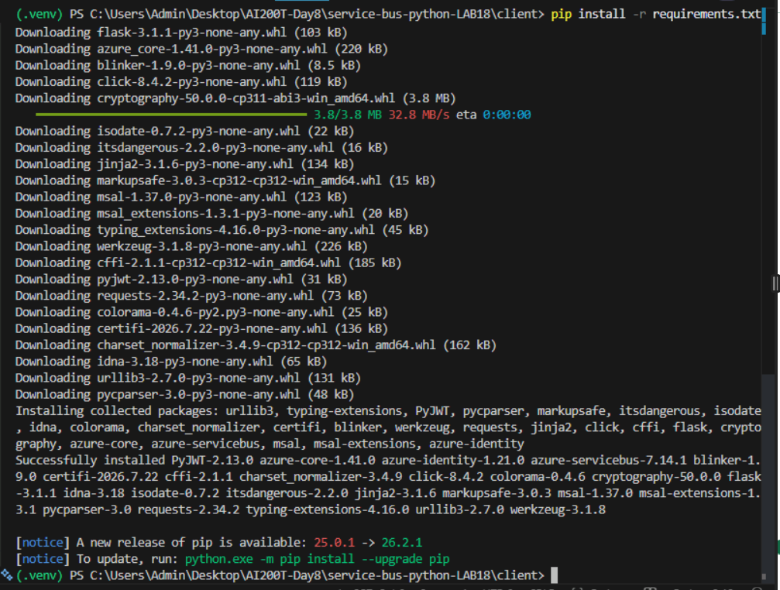
Run the app
In this section, you run the completed Flask application to perform various Service Bus messaging operations. The app provides a web interface that lets you send messages, process them with peek-lock delivery, inspect the dead-letter queue, and test topic messaging with filtered subscriptions.
- Run the following command in the terminal to start the app. Refer to the commands from earlier in the exercise to activate the environment, if needed, before running the command. If you navigated away from the client directory, run cd client first.
TypeCopy
python app.py
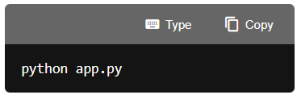
- Open a browser and navigate to http://localhost:5000 to access the app.
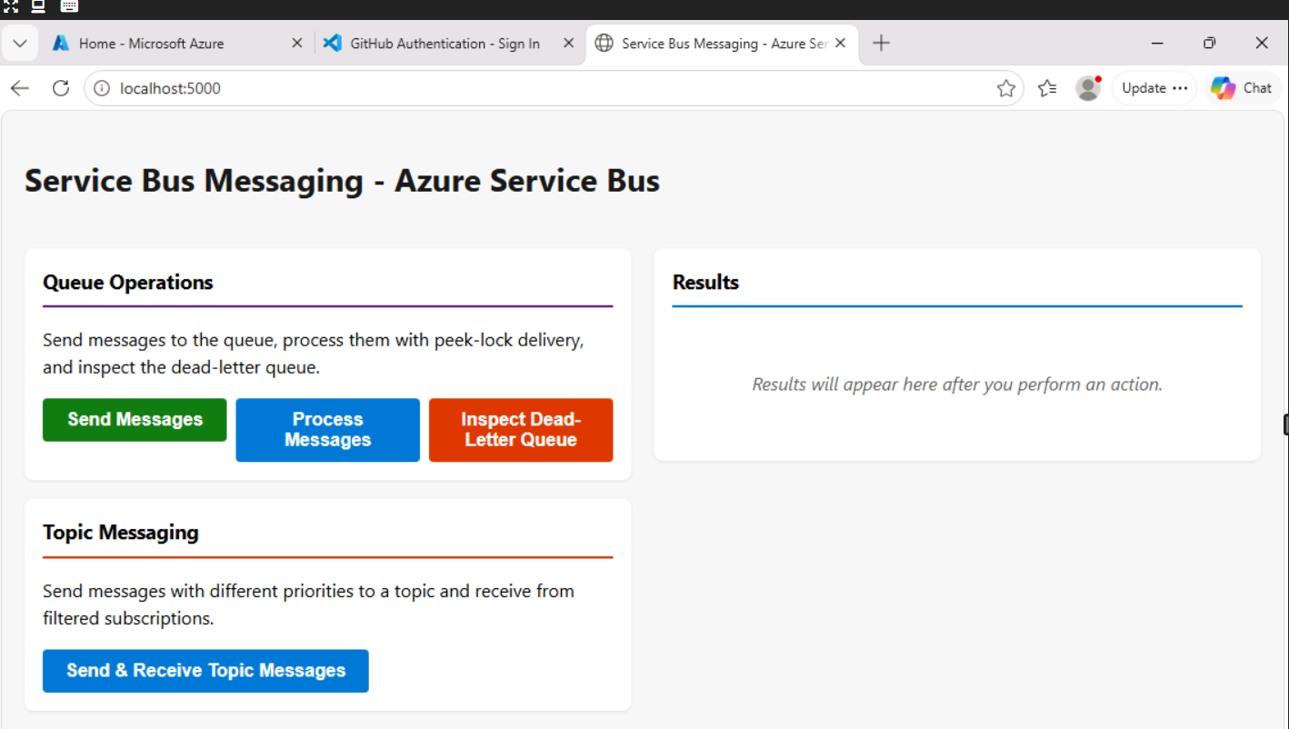
- Select Send Messages in the left panel. This sends three messages to the queue: two with valid JSON payloads representing inference requests, and one with intentionally malformed JSON. The results in the right panel confirm each message was sent along with its correlation ID and type.
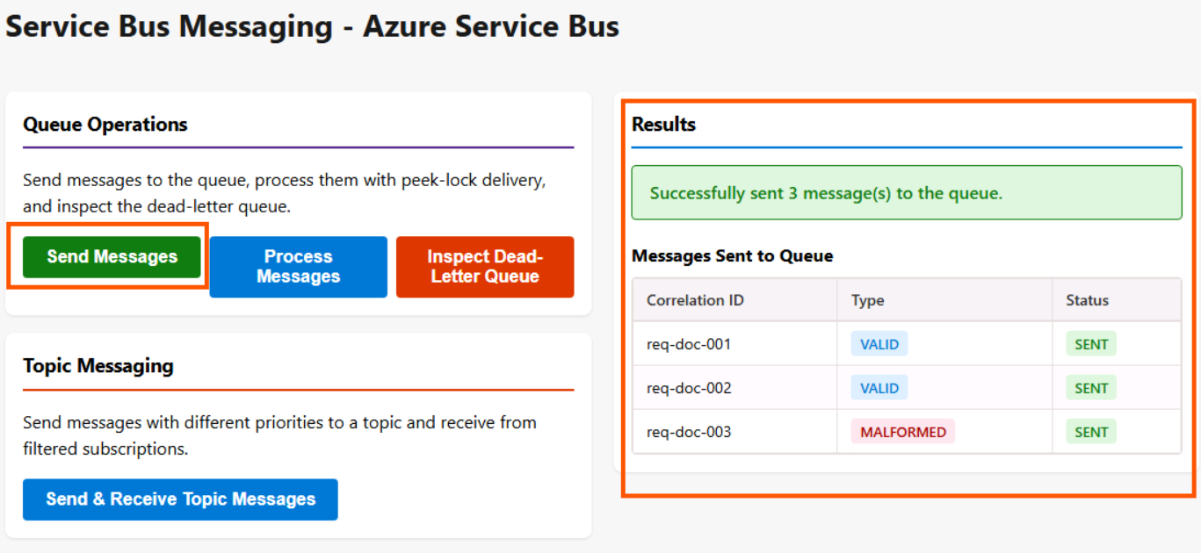

- Select Process Messages. This receives the three messages from the queue using peek-lock delivery. The processor validates each message's JSON payload, completes the two valid messages, and dead-letters the malformed message with a reason of MalformedPayload. The results show the status of each message after processing.
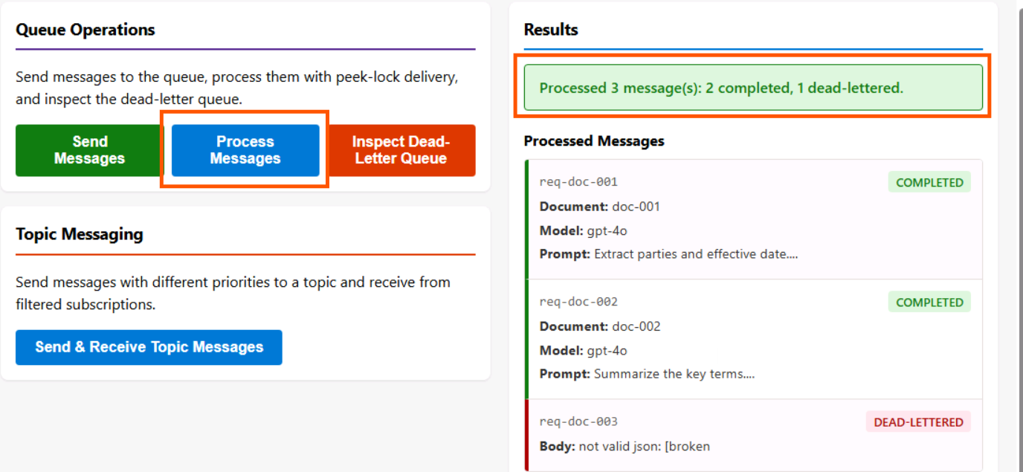
- Select Inspect Dead-Letter Queue. This reads the dead-lettered message and displays its diagnostic information, including the dead-letter reason, error description, and delivery count. The dead-letter queue captures messages that couldn't be processed so you can investigate failures.
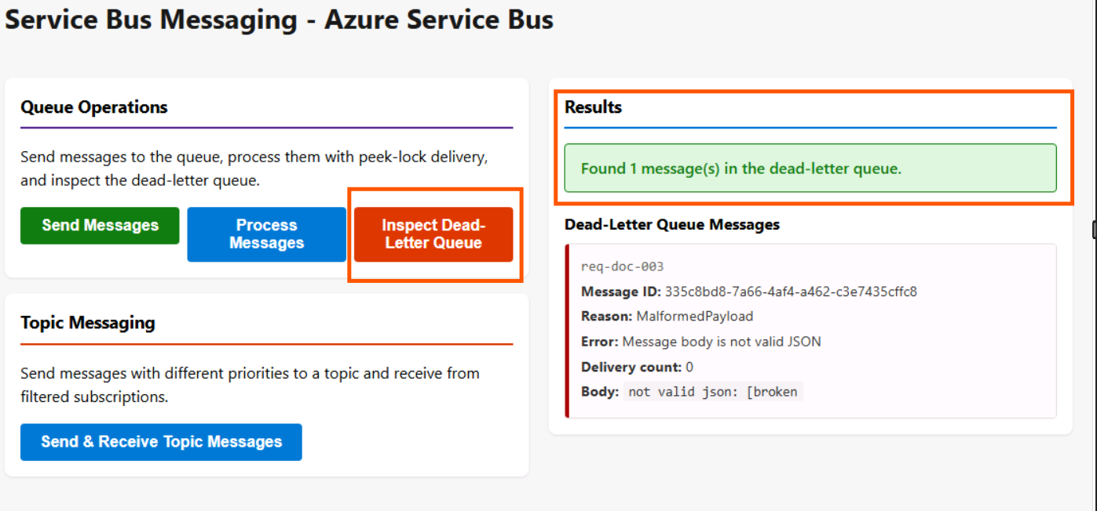
- Select Send & Receive Topic Messages. This sends five messages to the inference-results topic, each with a different priority level. It then reads from both subscriptions to demonstrate filtered delivery. The notifications subscription receives all five messages, while the high-priority subscription receives only the messages where the priority property equals high.
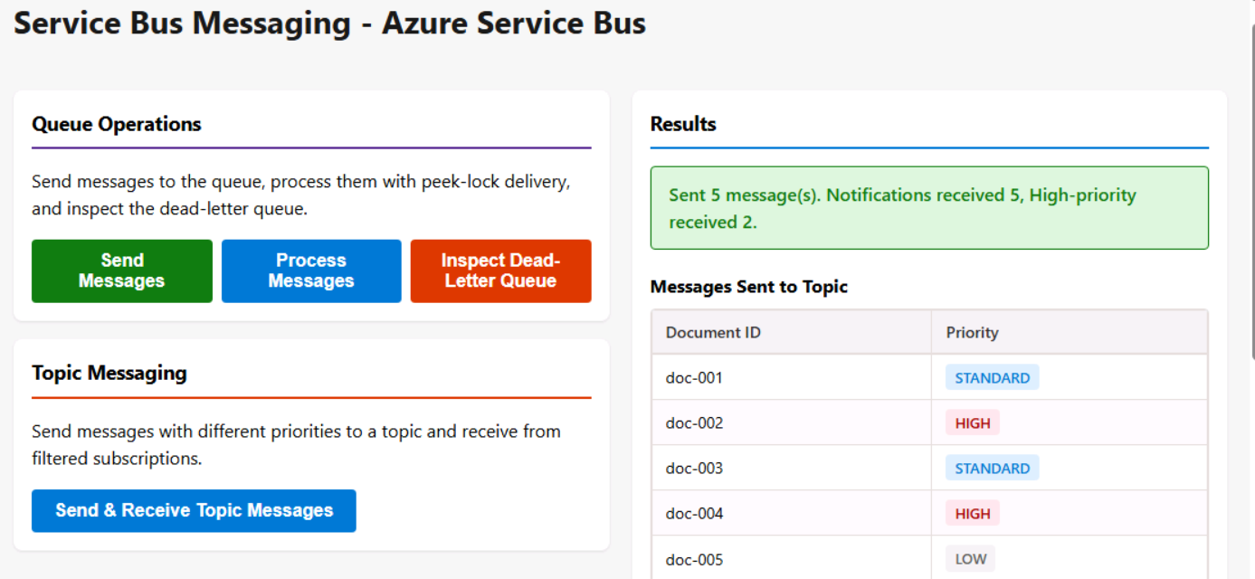
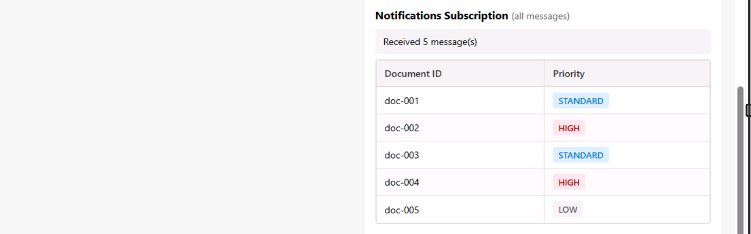
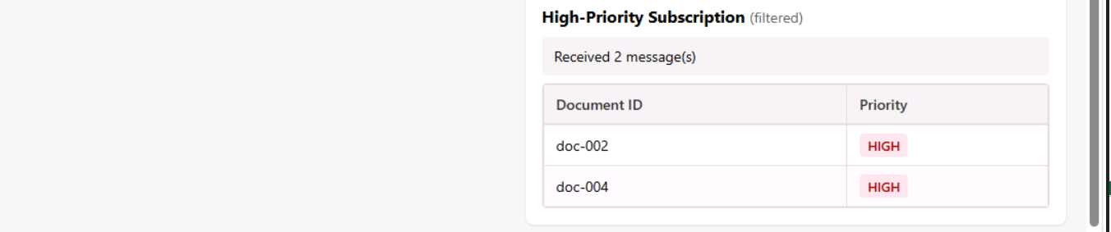
Clean up resources
Now that you finished the exercise, you should delete the cloud resources you created to avoid unnecessary resource usage.
- Run the following command in the VS Code terminal to delete the resource group, and all resources in the group. Replace \ with the name you choose earlier in the exercise. The command will launch a background task in Azure to delete the resource group.
TypeCopy
az group delete --name <rg-name> --no-wait --yes
CAUTION: Deleting a resource group deletes all resources contained within it. If you chose an existing resource group for this exercise, any existing resources outside the scope of this exercise will also be deleted.
Troubleshooting
If you encounter issues while completing this exercise, try the following troubleshooting steps:
Verify Azure Service Bus namespace deployment
- Navigate to the Azure portal and locate your resource group.
- Confirm that the Service Bus namespace shows a Provisioning State of Succeeded.
- Verify the namespace tier is Standard (required for topics and subscriptions).
Check messaging entities
- Run the deployment script's Check deployment status option to verify the queue, topic, subscriptions, and SQL filter were all created successfully.
- If any entities are missing, run the Create messaging entities option again.
Check code completeness and indentation
- Ensure all code blocks were added to the correct sections in service_bus_functions.py between the appropriate BEGIN/END comment markers.
- Verify that Python indentation is consistent (use spaces, not tabs) and that all code aligns properly within functions.
- Confirm that no code was accidentally removed or modified outside the designated sections.
Verify environment variables
- Check that the .env file exists in the project root and contains the SERVICE_BUS_FQDN value.
- Ensure you ran source .env (Bash) or . ..env.ps1 (PowerShell) to load environment variables into your terminal session.
- If variables are empty, re-run source .env (Bash) or . ..env.ps1 (PowerShell).
Check authentication
- Confirm you are logged in to Azure CLI by running az account show.
- Verify the Azure Service Bus Data Owner role is assigned to your account by checking the role assignments in the Azure portal or running the deployment script's option to assign the role again.
Check Python environment and dependencies
- Confirm the virtual environment is activated before running the app.
- Verify that all packages from requirements.txt were installed successfully by running pip list.

Congratulations
You have successfully completed this lab. Click End to mark the lab as Complete.

